Introduction to HTML/CSS
1. How are inline and block elements different from each other?
A block-level element always starts on a new line and takes up the full width available (stretches out to the left and right as far as it can).
<div>Hello World</div>
An inline element does not start on a new line and only takes up as much width as necessary.
This is an inline <span> element inside a paragraph.
<span>Hello World</span>

2.Explain the difference between visibility:hidden and display:none
display:none means that the tag in question will not appear on the page at all (although you can still interact with it through the dom). There will be no space allocated for it between the other tags. visibility:hidden means that unlike display:none , the tag is not visible, but space is allocated for it on the page.
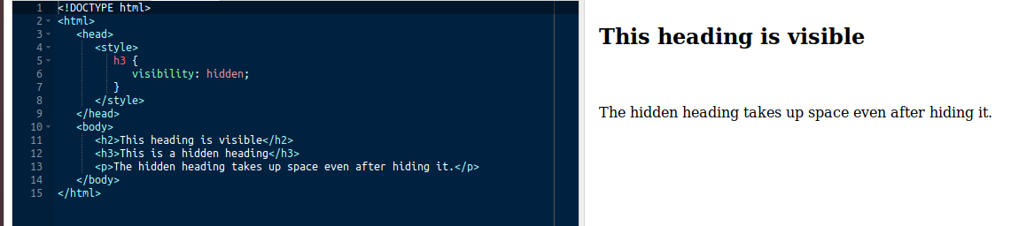
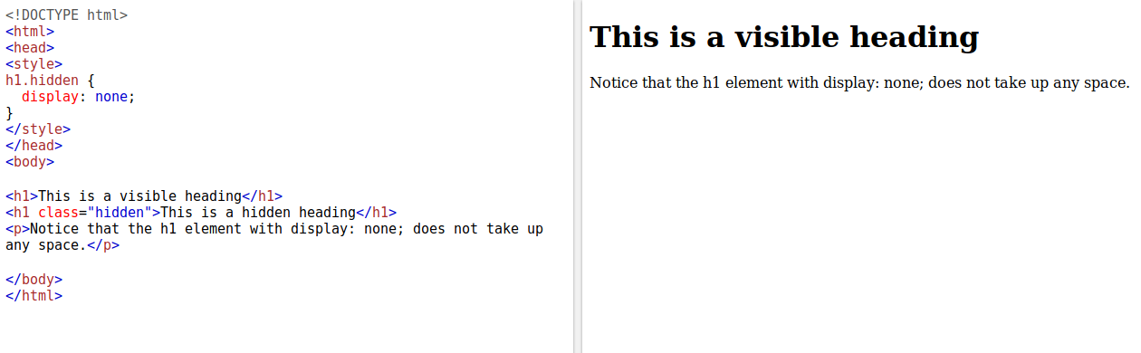

3. Explain the clear and float properties.
Float is used to specify how an element will float with respect to the other while clear will specifies what elements can float beside the cleared element and on which side.
4. explain difference between absolute, relative,fixed and static.
Static - this is the default value, all elements are in order as they appear in the document.
Relative - the element is positioned relative to its normal position.
Absolute - the element is positioned absolutely to its first positioned parent.
Fixed - the element is positioned related to the browser window.
5. Write the HTML code to create a table in which there are 4 columns( ID , Employee Name, Designation, Department) and at least 6 rows. Also do some styling to it.
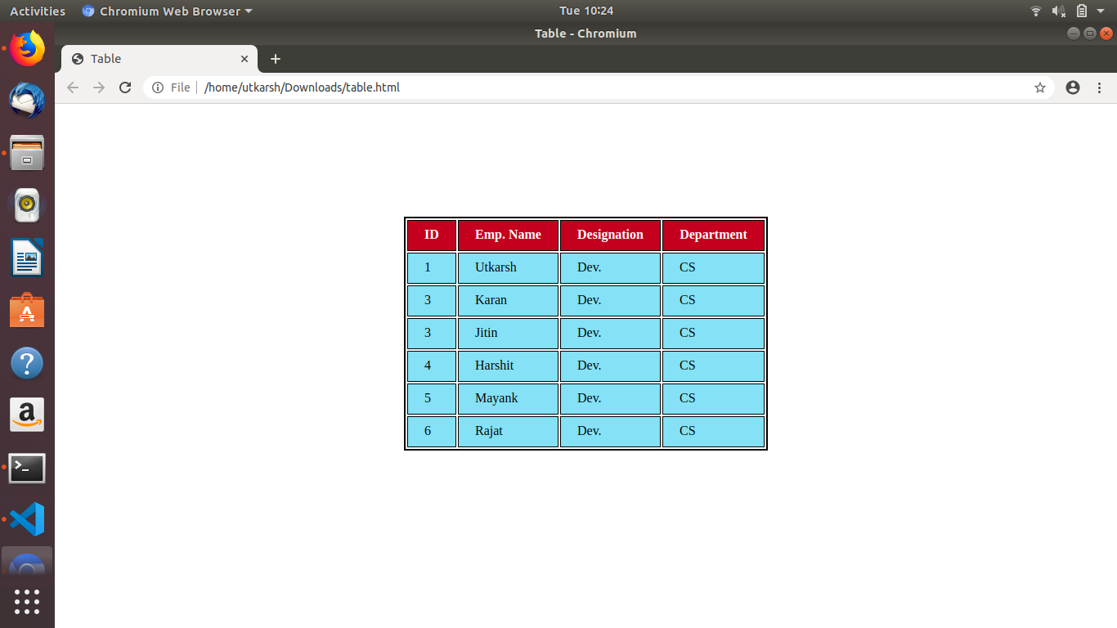
6. Why do we use meta tags?
The <meta> tag provides metadata about the HTML document. Metadata will not be displayed on the page, but will be machine parsable.Meta elements are typically used to specify page description, keywords, author of the document, last modified, and other metadata.
<meta name="viewport" content="width=device-width, initial-scale=1.0">

7. Explain box model.
All HTML elements can be considered as boxes. In CSS, the term "box model" is used when talking about design and layout.
The CSS box model is essentially a box that wraps around every HTML element. It consists of: margins, borders, padding, and the actual content. The image below illustrates the box model:
- Content - The content of the box, where text and images appear
- Padding - Clears an area around the content. The padding is transparent
- Border - A border that goes around the padding and content
- Margin - Clears an area outside the border. The margin is transparent
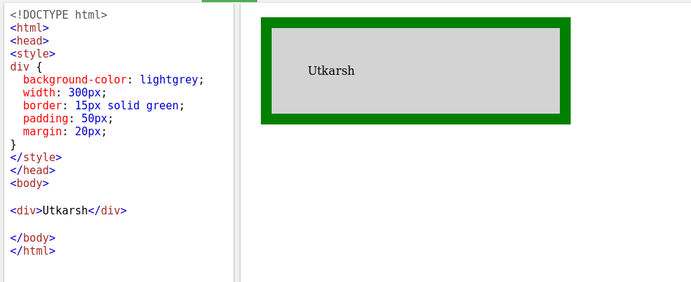
8. What are the different types of CSS Selectors?
CSS selectors are used to select the content you want to style. Selectors are the part of CSS rule set. CSS selectors select HTML elements according to its id, class, type, attribute etc.
There are several different types of selectors in CSS.
- CSS Element Selector
- CSS Id Selector
- CSS Class Selector
- CSS Universal Selector
- CSS Group Selector

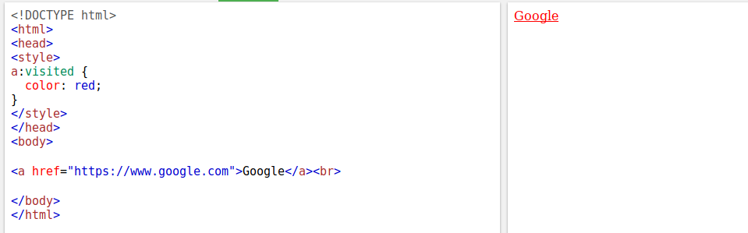

9. Define Doctype.
A doctype or document type declaration is an instruction which tells the web browser about the markup language in which the current page is written. The Doctype is not an element or tag, it lets the browser know about the version of or standard of HTML or any other markup language that is being used in the document.

10. Explain 5 HTML5 semantic tags.
<header> - used to give the header to a webpage
<footer>- used to give the footer to a webpage
<figure>- used to have figure in our pages
<figcaption>- used to give caption to our figure
<article>- used to create article in our pages.
11. Create HTML for web-page.jpg (check resources, highest weightage for answers)
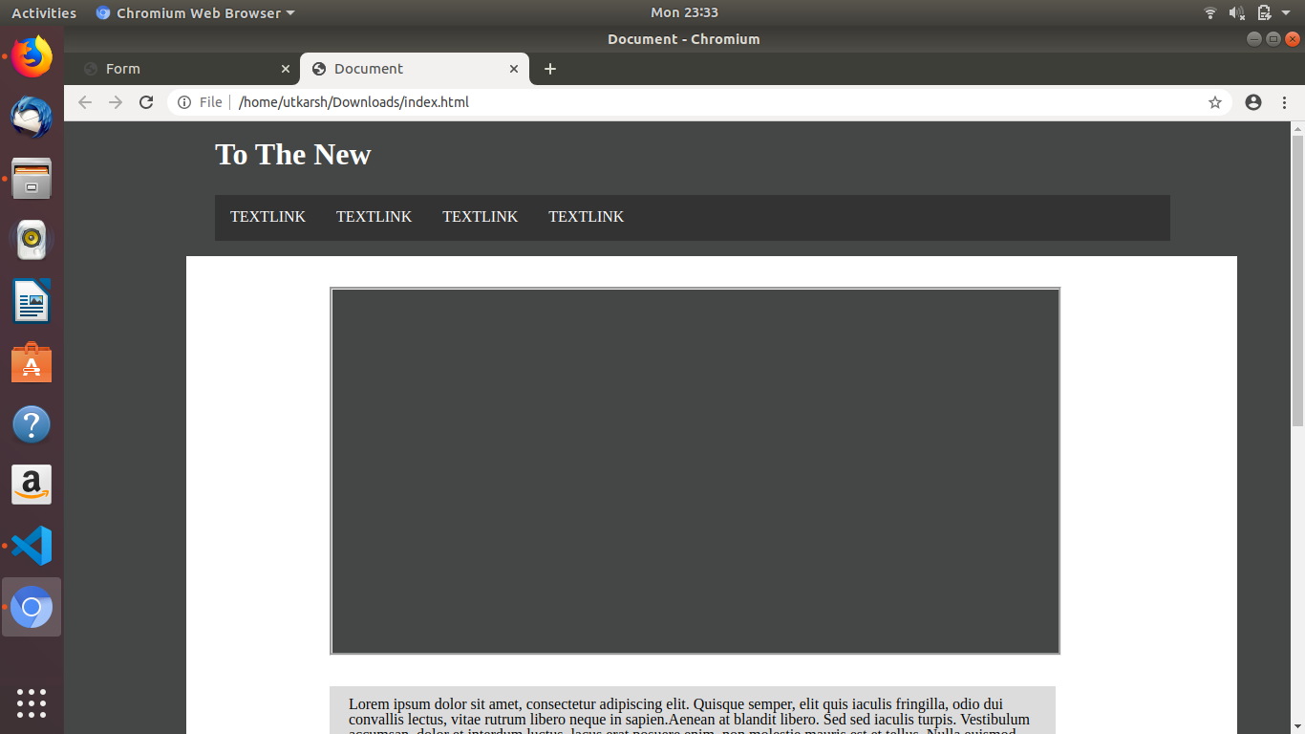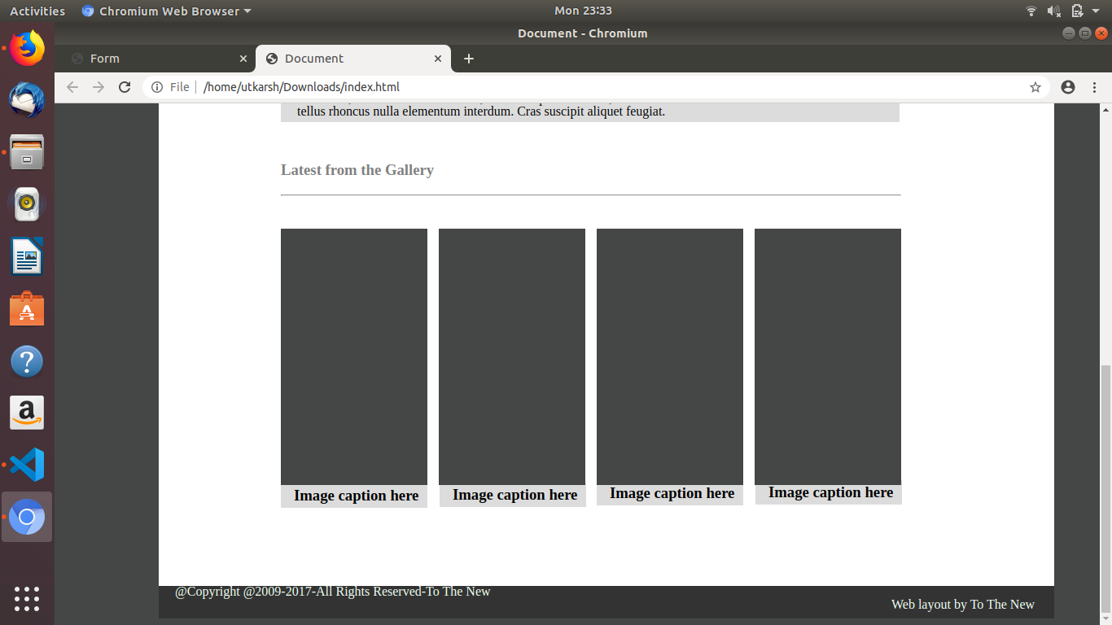

12. Create HTML for form.png (check resources, highest weightage for answers)
Open in Chromium
